## Lab # 1: Introduction to MS Access (Database, Tables)

###### Objective:

1-Introduction to MS ACCESS 2-How to create tables.

1. How to create queries, reports, and forms.

###### Scope:

The student should know the following:

* + MS Access basics.
  + MS Access Practice.
  + Basic exercises.

###### Useful Concepts:

Table name, its column name and column’s datatypes.

How to create queries on tables. Forms and Reports.

###### Discussion:

Queries, Reports, Forms.

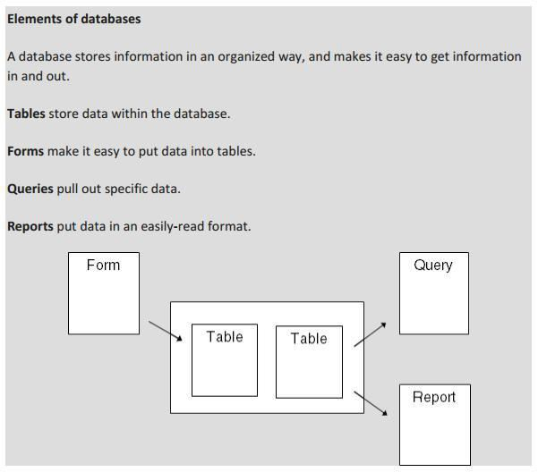

CS203 Database Systems Lab Manual

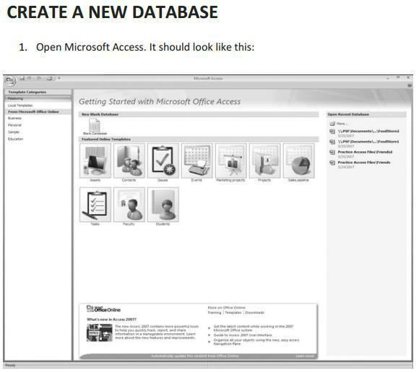

CS203 Database Systems Lab Manual

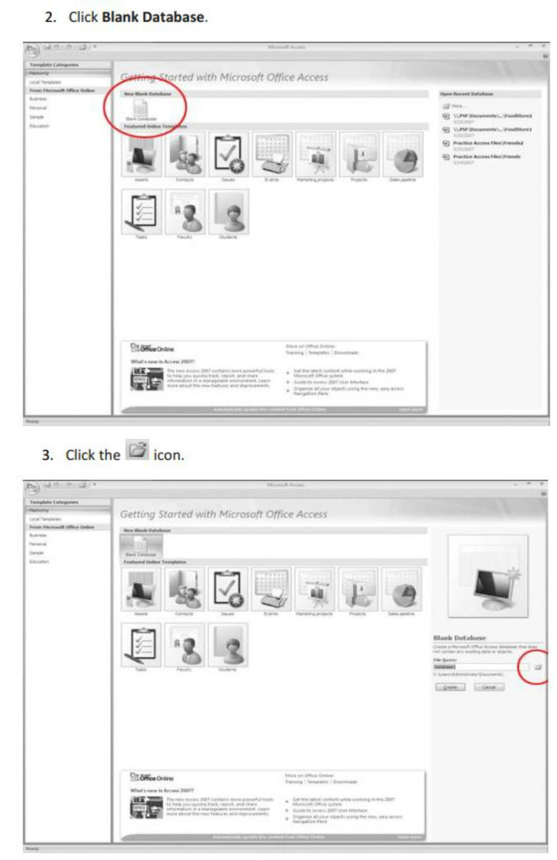

CS203 Database Systems Lab Manual

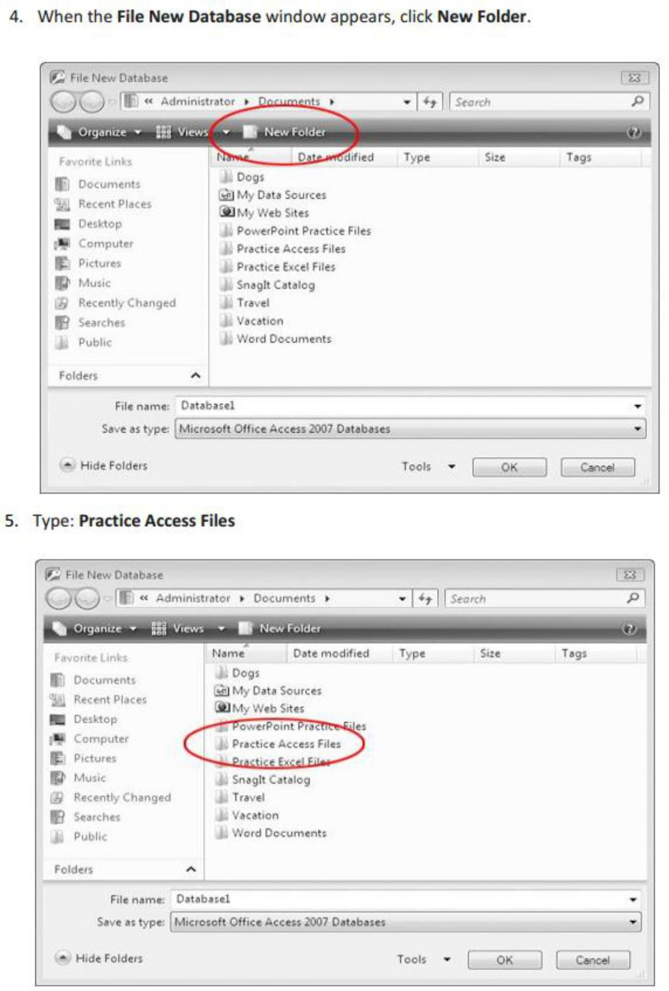

CS203 Database Systems Lab Manual

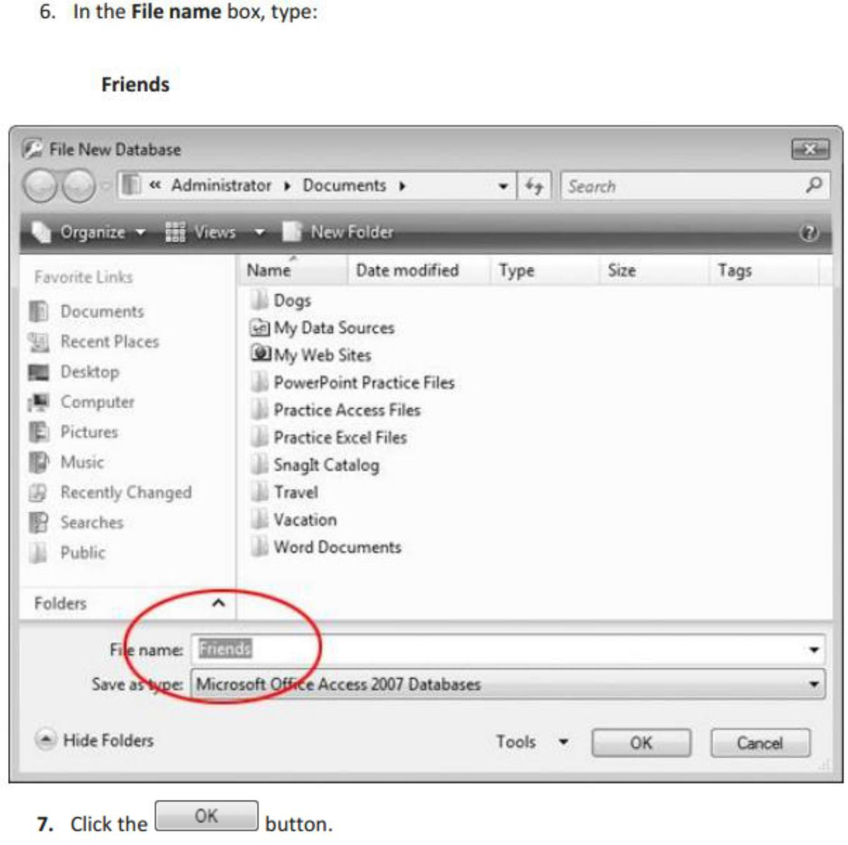

CS203 Database Systems Lab Manual

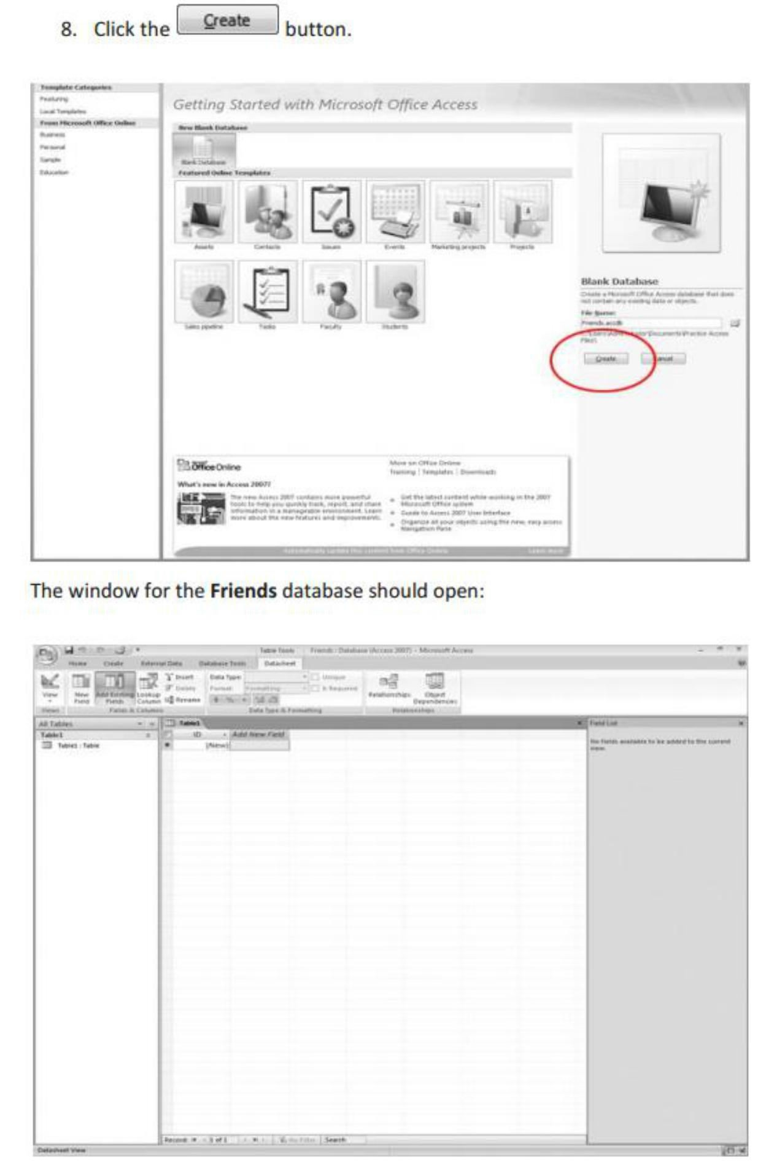

CS203 Database Systems Lab Manual

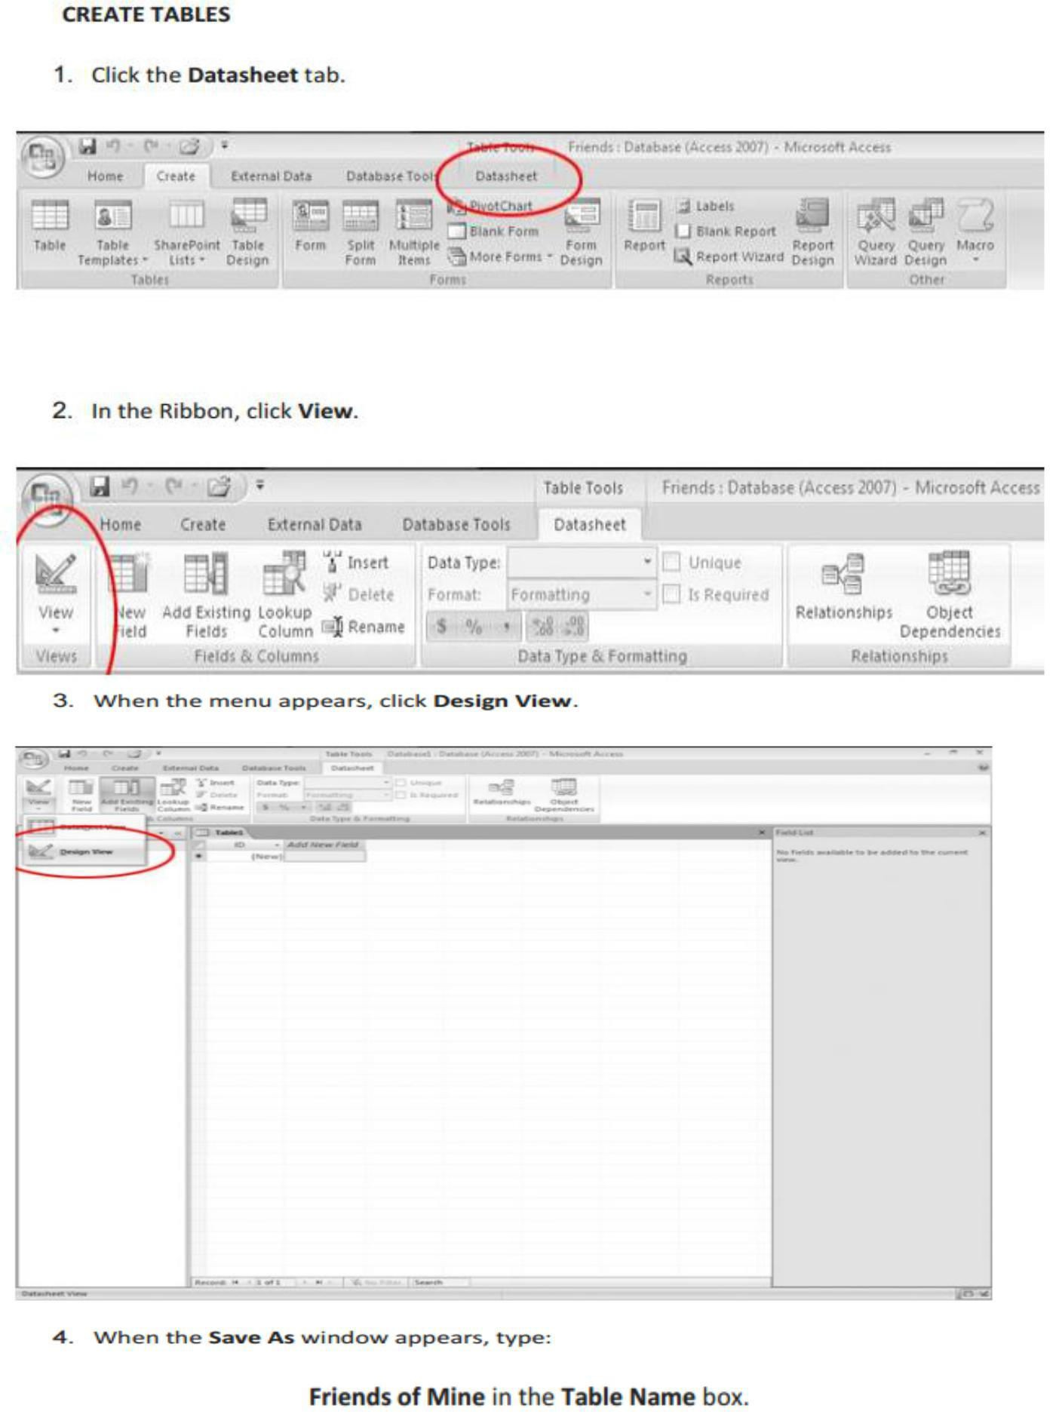

CS203 Database Systems Lab Manual

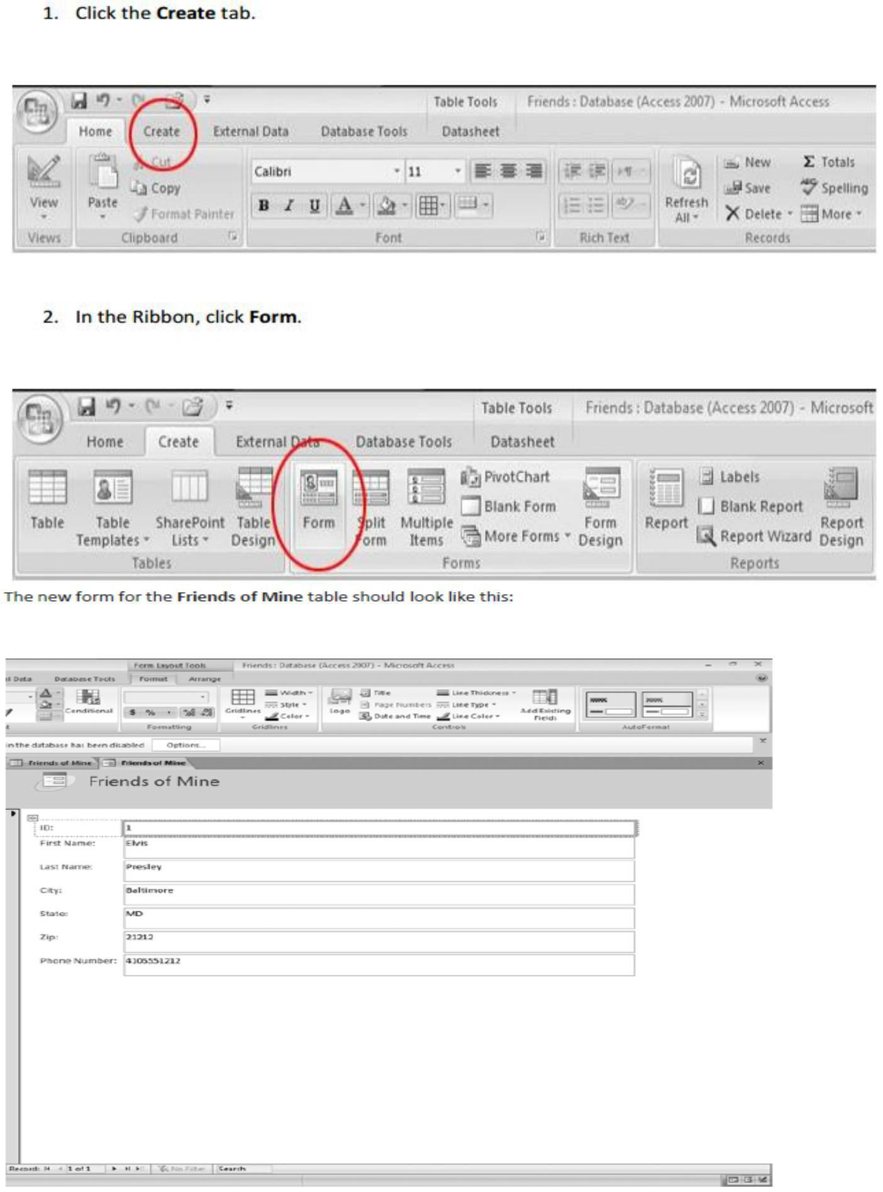

CS203 Database Systems Lab Manua